**Table of Content**

**Chapter Page**

1. **Introduction 04**
   1. Introduction of research problem 05
   2. Literature Overview 05
   3. Scope 05
   4. Motivation 05
   5. Objectives 06
2. **About the System 07**
   1. Technologies used 08
      1. Anvil 08
      2. Anaconda Navigator 08
      3. Jupyter Notebook 08
      4. Python 08
      5. Python Libraries 09
   2. Used trained model in system 11
      1. Dog vs Cat Model 11
         1. Dataset 11
         2. Model 11
         3. Result 12
      2. Dog Breed Identifier 13
         1. Dataset 13
         2. Model 14
         3. Result 14
      3. Pet Identifier (Used for background removal technique) 15
         1. Dataset 15
         2. Model 15
         3. Result 16
      4. Pet Identifier (For individual body and face parts) 16
         1. Dataset 16
         2. Model 16
         3. Result 17
   3. Theory used in system 17
      1. Machine Learning vs Deep Learning 17
      2. Convolution Neural Network 17
         1. Convolution 18
         2. Non-linearity (ReLU) 19
         3. Pooling 20
         4. Fully Connected Layer 21
      3. Image Processing 22
         1. Resize/crop 23
         2. Dimensionality Reduction 23
         3. Data Augmentation 23
      4. Training/Testing Set 24
      5. Feature Extraction 25
      6. Detailed VGG16 Model 25
   4. Detector developed during system implementation 26
      1. Dog Body Parts Detector 26
      2. Face Parts Detector 27
   5. API used in System 27
      1. Remove Background 27
   6. Tools Used During Implementation 28
      1. LabelImg 28
      2. Anvil 29
         1. Connection 30
         2. Layouts 30
3. **Analysis 32**
   1. Sequence Diagram 33
      1. Benefits of Sequence Diagram 33
      2. Login Scenario 33
      3. Predict Dog Breed 34
      4. Dog Face part Detector 35
   2. Usecase Diagram 35
      1. Benefits of sequence Diagram 35
      2. System usecase Diagram 36
4. **Design 37**
   1. Dataset 38
      1. User Details 38
      2. Cat or Dog Feedback 38
      3. Breed Feedback 38
   2. Validation 39
      1. Login Validation 39
      2. Dog Face Validation 40
5. **Implementation 41**
   1. Home Page 42
   2. Cat vs Dog Classifier 42
   3. Dog Breed Classifier 43
   4. Cat Breed Classifier 44
   5. Feedback form for Cat vs Dog Classifier 45
   6. Feedback form for Dog Classifier 45
   7. Pet Trainer (using background extraction) 46
   8. Pet Prediction 47
   9. Body Parts Detector 47
   10. Face Parts Detector 48
   11. Pet Trainer 48
6. **Conclusion and Future Extension 49**
   1. Conclusion 50
   2. Future Extension 51

**List of Figures**

Fig 2.1 Code Snip1 12

Fig 2.2 Model Training Result 12

Fig 2.3 Model Training Validation 13

Fig 2.4 Code Snip2 13

Fig 2.5 Code Snip 3 14

Fig 2.6 Train and Validation 14

Fig 2.7 Vgg16 model 17

Fig 2.8 CNN Image Classification 18

Fig 2.9 Matrix of 5 x 5 19

Fig 2.10 Matrix of 3 x 3 19

Fig 2.11 Convolution of two matrix 19

Fig 2.12 Relu representation on graph 20

Fig 2.13 Max pooling 21

Fig 2.14 Fully Connected layer 22

Fig 2.15 Code Snip4 23

Fig 2.16 Data Augmentation 23

Fig 2.17 VGG-16 Architecture 26

Fig 2.18 Dog Body Parts 26

Fig 2.19 Facial Features 27

Fig 2.20 Working of Remove-Bg 27

Fig 2.21 Code Snip5 28

Fig 2.22 LabelImg 29

Fig 2.23 Code Snip6 30

Fig 2.24 Anvil Layout 30

Fig 2.25 Code Snip7 31

Fig 3.1 Login Scenario 33

Fig 3.2 Breed Prediction Scenario 34

Fig 3.3 Dog Face Part DetectionScenario 35

Fig 3.4 Usecase Diagram 36

Fig 4.1 User Data 38

Fig 4.2 Cat vs Dog Feedback Data 38

Fig 4.3 Breed Feedback Data 39

Fig 4.4 Login Signup Page 39

Fig 4.5 Dog Face Detector 40

Fig 5.1 Anvil Snip 1 42

Fig 5.2 Anvil Snip 2 42

Fig 5.3 Anvil Snip 3 43

Fig 5.4 Anvil Snip 4 43

Fig 5.5 Anvil Snip 5 44

Fig 5.6 Anvil Snip 6 44

Fig 5.7 Anvil Snip 7 45

Fig 5.8 Anvil Snip 8 45

Fig 5.9 Anvil Snip 9 45

Fig 5.10 Anvil Snip 10 46

Fig 5.11 Anvil Snip 11 46

Fig 5.12 Anvil Snip 12 47

Fig 5.13 Anvil Snip 13 47

Fig 5.14 Anvil Snip 14 48

Fig 5.15 Anvil Snip 15 48

**Chapter 1**

Introduction

_______________________________________________________________________________________________________

1. **INTRODUCTION**

**1.1 Introduction to Research Problem**

The research done for animals in the field of Machine Learning for identifying an animal and getting to know its nomenclature is only done up-to the brim. Thus, here we are taking it further and try to classify the type of animal and it’s breed along with analysis of few other parameters to get to know the animal in more depth just by looking at the image.

Literature on animal biometry is scarce. Computer Vision is mainly interested in animals as members of large classes, not as individuals. The interest in animals as individuals come mainly from wildlife researchers, for whom the identification of specimens is critical to determine ecological pattern.

In this paper, we inaugurate that promising avenue by pursuing face recognition for dogs. Although literature on pet biometry is to say the least scarce, human face recognition is a well-established domain with a vast literature. The paper would help in identifying the type of animal it is, breed of the animal and pet.

**1.2 Literature Overview**

The research work we could find based on animal data set was only based on dog’s as individual as resemblance to a human face and detect faces of the dog, which were just barely able to detect the faces with an accuracy of 76% under ideal conditions.

**1.3 Scope**

This research is to show that, wildlife researchers, government, environmentalists who thrive to protect and identify the wildlife(animals) can easily with the help of their mobile devices such as computers(laptop) and mobile phones can have a timely analysis of the breed classification and also identification individual animal.

As far as the customers are considered, pet identification application, which can help them find their pets(dogs) if lost or identify their own pets when sheltered at a pet care. This way we have a broad scope for attaining attention from the animal lovers and zoologist who can gather exact information in just a few seconds.

**1.4 Motivation**

Motivation for developing an application included several important points. There is almost no work done in field of animal with respect to identifying difference between dogs of same breed using technologies like OpenCV and Deep Learning. Developed application will help to explore more in field of Machine Learning with respect to animals.

**1.5 Objectives**

The main object was lack of research done with reference to dog. For example, there was no pretrained model was available which can separate body parts of bog. However, similar for humans is available. Another objective came in implementation was lack of availability of proper dataset. For instance, there was only dataset of 133 breeds of dogs was available, which we increase to 175.

**Chapter 2**

About the system

_______________________________________________________________________________________________________

1. **About the system**

**2.1 TECHNOLOGIES USED**

**2.1.1 Anvil**

Anvil is a platform for building and hosting full-stack web apps written entirely in Python. Drag & drop your UI, then write Python on the front-end and back-end to make it all work. Web development has never been this easy (or fast) Anvil is a tool in the Platform as a Service category of a tech stack.

**2.1.2 Anaconda Navigator:**

Anaconda Navigator is a desktop graphical user interface (GUI) included in Anaconda distribution that allows users to launch applications and manage conda packages, environments and channels without using [command-line commands](https://en.wikipedia.org/wiki/Command-line_interface). Navigator can search for packages on Anaconda Cloud or in a local Anaconda Repository, install them in an environment, run the packages and update them. It is available for [Windows](https://en.wikipedia.org/wiki/Windows), macOS and [Linux](https://en.wikipedia.org/wiki/Linux).

Navigator is an easy, point-and-click way to work with packages and environments without needing to type conda commands in a terminal window. You can use it to find the packages you want, install them in an environment, run the packages, and update them – all inside Navigator.

**2.1.3 Jupyter Notebook**

The Jupyter Notebook is an open-source web application that allows you to create and share documents that contain live code, equations, visualizations and narrative text. Uses includes data cleaning and transformation, numerical simulation, statistical modelling, data visualization, machine learning, and much more. The Jupyter Notebook App is a server-client application that allows editing and running [notebook documents](https://jupyter-notebook-beginner-guide.readthedocs.io/en/latest/what_is_jupyter.html#notebook-document) via a web browser. The Jupyter Notebook App can be executed on a local desktop requiring no internet access (as described in this document) or can be installed on a remote server and accessed through the internet.

In addition to displaying/editing/running notebook documents, the Jupyter Notebook App has a “Dashboard” ([Notebook Dashboard](https://jupyter-notebook-beginner-guide.readthedocs.io/en/latest/what_is_jupyter.html#dashboard)), a “control panel” showing local files and allowing to open notebook documents or shutting down their [kernels](https://jupyter-notebook-beginner-guide.readthedocs.io/en/latest/what_is_jupyter.html#kernel).

**2.1.4 Python**

Python is an interpreted, object-oriented, high-level programming language with dynamic semantics. Its high-level built in data structures, combined with dynamic typing and dynamic binding, make it very attractive for Rapid Application Development, as well as for use as a scripting or glue language to connect existing components together.

**2.1.5 Python Libraries**

Python library is a collection of functions and methods that allows you to perform many actions without writing your code. Each library in Python contains a huge number of useful modules that you can import for your everyday programming.

Various libraries in this project are:

**1.Numpy**

NumPy is a general-purpose array-processing package. It provides a high-performance multidimensional array object, and tools for working with these arrays.

It is the fundamental package for scientific computing with Python. It contains various features including these important ones:

* A powerful N-dimensional array object
* Sophisticated (broadcasting) functions
* Tools for integrating C/C++ and Fortran code
* Useful linear algebra, Fourier transform, and random number capabilities

Besides its obvious scientific uses, NumPy can also be used as an efficient multi-dimensional container of generic data.

**2.Keras**

Keras is a high-level neural networks API, written in Python and capable of running on top of [TensorFlow](https://github.com/tensorflow/tensorflow), [CNTK](https://github.com/Microsoft/cntk), or [Theano](https://github.com/Theano/Theano). It was developed with a focus on enabling fast experimentation*.*Being able to go from idea to result with the least possible delay is key to doing good research*.*

Use Keras deep learning library that:

* Allows for easy and fast prototyping (through user friendliness, modularity, and extensibility).
* Supports both convolutional networks and recurrent networks, as well as combinations of the two.
* Runs seamlessly on CPU and GPU.

**3.TensorFlow**

TensorFlow is an end-to-end open source platform for machine learning. It has a comprehensive, flexible ecosystem of tools, libraries and community resources that lets researchers push the state-of-the-art in ML and developers easily build and deploy ML powered applications.

**4.TQDM**

TQDM is a progress bar library with good support for nested loops and Jupyter/IPython notebooks.

* TQDM supports nested progress bars. If you have Keras fit and predict loops within an outer TQDM loop, the nested loops will display properly.
* TQDM supports Jupyter/IPython notebooks.

**5.Scikit-learn**

Scikit-learn provides a range of supervised and unsupervised learning algorithms via a consistent interface in Python. It is licensed under a permissive simplified BSD license and is distributed under many Linux distributions, encouraging academic and commercial use.

The library is built upon the SciPy (Scientific Python) that must be installed before you can use scikit-learn. The vision for the library is a level of robustness and support required for use in production systems. This means a deep focus on concerns such as ease of use, code quality, collaboration, documentation and performance. Although the interface is Python, c-libraries are leverage for performance such as numpy for arrays and matrix operations, [LAPACK](http://www.netlib.org/lapack/), [LibSVM](http://www.csie.ntu.edu.tw/~cjlin/libsvm/) and the careful use of cython.

**6.Matplotlib**

Matplotlib is a Python 2D plotting library which produces publication quality figures in a variety of hardcopy formats and interactive environments across platforms. Matplotlib can be used in Python scripts, the Python and [IPython](http://ipython.org/) shells, the [Jupyter](http://jupyter.org/) notebook, web application servers, and four graphical user interface toolkits. Matplotlib tries to make easy things easy and hard things possible. You can generate plots, histograms, power spectra, bar charts, error charts, scatterplots, etc., with just a few lines of code. For examples, see the [sample plots](https://matplotlib.org/tutorials/introductory/sample_plots.html) and [thumbnail gallery](https://matplotlib.org/gallery/index.html).

For simple plotting the pyplot module provides a MATLAB-like interface, particularly when combined with IPython. For the power user, you have full control of line styles, font properties, axes properties, etc, via an object oriented interface or via a set of functions familiar to MATLAB users.

**7.LabelImg**

LabelImg is a graphical image annotation tool. It is written in Python and uses Qt for its graphical interface. Annotations are saved as XML files in PASCAL VOC format, the format used by [ImageNet](http://www.image-net.org/). Besides, it also supports YOLO format.

**8.OpenCV**

OpenCV (Open Source Computer Vision Library) is an open source computer vision and machine learning software library. OpenCV was built to provide a common infrastructure for computer vision applications and to accelerate the use of machine perception in the commercial products. Being a BSD-licensed product, OpenCV makes it easy for businesses to utilize and modify the code.

It has C++, Python, Java and MATLAB interfaces and supports Windows, Linux, [Android](https://opencv.org/android/) and Mac OS. OpenCV leans mostly towards real-time vision applications and takes advantage of MMX and SSE instructions when available. A full-featured [CUDA](https://opencv.org/cuda/)and [OpenCL](https://opencv.org/opencl/) interfaces are being actively developed right now. There are over 500 algorithms and about 10 times as many functions that compose or support those algorithms. OpenCV is written natively in C++ and has a templated interface that works seamlessly with STL containers.

**2.2 Used trained model in system**

**2.2.1 Dog VS Cat Model**

**2.2.1.1 Dataset**

In the first phase we start with gathering of data set.

The data sets gathered were as follows:

Kaggle

IIIT Oxford Data set

Getty Images

The dataset from Kaggle was downloaded, in the 250x250 pixels resolution, the images which were not in the given dimensions were converted/cropped to match the dataset and all the images were then finally resized to 224x224 pixels for the GPU and RAM to support the large data set for training.

The images captured were augmented too as, it would generate more variations and make the literature richer dataset for training.

This way we were able to augment the data and have a richer set of images for training purpose.

Total number of Dog images - 12547

Total number of Cat images - 13000

Total number of images in Training Dataset - 17000

Total number of images in Validation Dataset - 7547

Total number of images in Test Dataset – 1000

Dimensions after Image Preprocessing – (224,224)

**2.2.1.2 Model**

The first basic trail model to train the dataset had the following configuration:-

|  |
| --- |
| model = Sequential() |
|  |
| model.add(Conv2D(32, (3, 3), input_shape=input_shape)) |
| model.add(Activation("relu")) |
| model.add(MaxPooling2D(pool_size=(2, 2))) |
|  |
| model.add(Conv2D(32, (3, 3))) |
| model.add(Activation("relu")) |
| model.add(MaxPooling2D(pool_size=(2, 2))) |
|  |
| model.add(Flatten()) |
|  |
| model.add(Dense(16)) |
| model.add(Activation("relu")) |
| model.add(Dropout(0.5)) |
| model.add(Dense(1)) |
| model.add(Activation(“RELU")) |
|  |
| model.compile(loss="binary_crossentropy", |
| optimizer=“adam", |
| metrics=["accuracy"]) |

**Fig 2.1** Code Snip 1

**2.2.1.3 Results**

Model (Training)

**Fig 2.2** Model Training Result

The validation accuracy is 77% in this case. Now we try to improve the accuracy by

refining the models and looking at the results.

**Fig 2.3** Model Training Validation

**2.2.2 Dog Breed Identifier (MODEL)**

**2.2.2.1 Dataset**

In this task the images of dogs were taken from Kaggle and Google.

Kaggle had a sorted list of 133 Dog Breeds and we extended its support to 175 Breeds by individually searching for breeds and classifying them for identification.

All the images of the dogs were placed under the directories of their own breed, by creating 175 directories and placing the images respectively under each breed. There 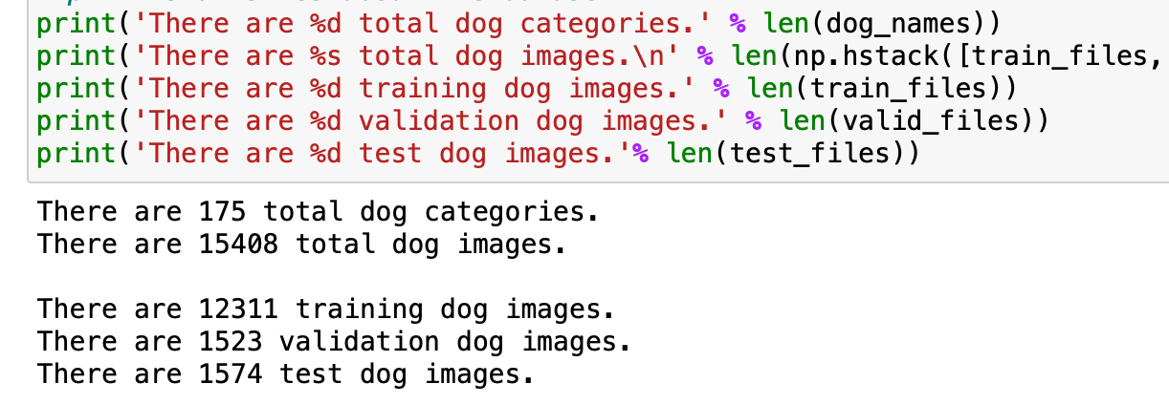is approximately 90 images of each breed.

**Fig 2.4** Code Snip2

Images are then converted to tensors, to make them understandable and reduce the dimensional sizes so to process faster for the Tensorflow to understand.

Dimensions after Image Preprocessing – (224,224)

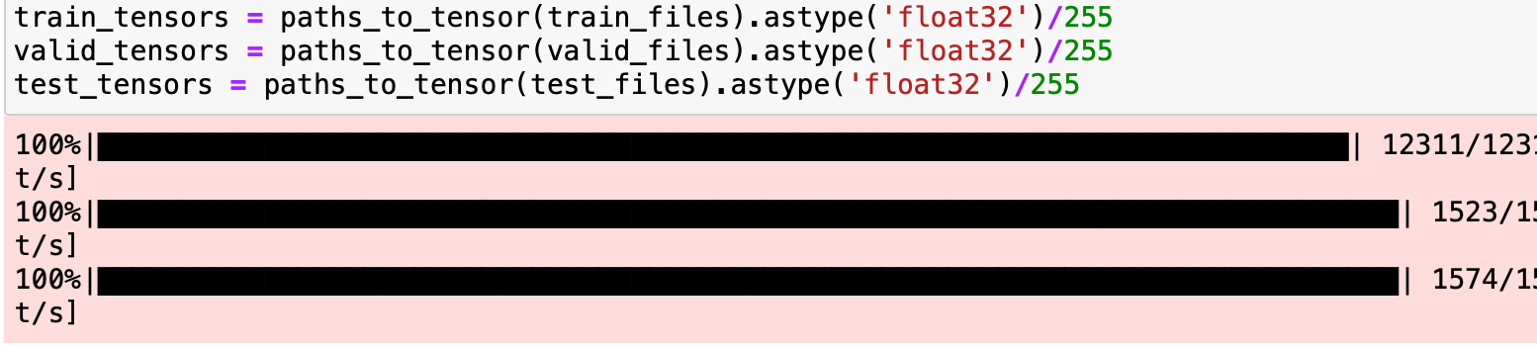

**Fig 2.5** Code Snip 3

**2.2.2.2 Model**

The model was defined as given here:

**Input size (in pixels)**: 224 x 224 pixels

– Number of layers in network: 1, 2, 3

– Normalization after pooling: Yes

– Filters in each layer (amount): 32, 64, 128, 512

– Size of the ﬁlters (pixels): 3, 5, 9

– Exponent of pooling layers (scalar): 1, 2, 10

– Stride of pooling layers (pixels): 1, 2

 **2.2.2.3 Results**

**Fig 2.6** Train and Validation

This shows we get accuracy of 93%. After a series of models and training time of approximately of 48hrs, we were able to achieve this accuracy for predicting the breeds based on the picture of the dog.

Out of the total breeds in the world we have sufficient dataset for around 175 breeds of dog and thus this model is devised for 175 Dog Breeds and can predict their breed. For this we had to try out different models and in the fourth iteration we had arrived at this model which had a greater accuracy than the previous models.

**2.2.3 Pet identifier** **(Used for background removal technique)**

This model has the aim to detect from a given set of images that is it your own pet or not. The use case is set as suppose someone has lost their pet or if you want to identify your dog from same breed of dogs then how would you be doing that? Hence this model was generated, and all the previous models were studied to design this model and propose a fruitful solution to this issue.

**2.2.3.1 Dataset**

The data had to be gathered manually for this set of issue. We had contacted a pet owner and captured the pet’s images manually using high quality DSLR(Canon EOS 500D), under different backgrounds and different angles to have a dynamic set of quality images which would result in training the model with the most amount of information that can be captured.

The images gathered were of German Shepard dog (Leo). The other images were of different German Shepard dogs already with us from the previous data set. Before sending images for training background of ever images were removed because if images were trained without removing background model would overfit and trained background instead of dog. To remove background from every image we used Removebg Api. Which provides functionality of removing background from image.

Total Number of Images (Leo) - 550

Total Number of Images (Other) – 600

Total Number of images in Training Dataset – 800

Total Number of images in Validation Dataset – 250

Total Number of images in Testing Dataset – 100

Dimensions after Image Preprocessing – (224,224)

**2.2.3.2 Model**

The inception pre-trained model was taken here to extract a great deal of information from the set of data. We used one hot encoding to train the model which would give the values [1,0] to Leo and [0,1] to others when the extraction of data is processed in the testing and trying set of given images and generate the hdf5 file.

The inception model was modified to custom our needs and extract only limited features so then parameters were modified as follows.

The model was modified as given here: -

**Input size (in pixels)**: 224 x 224 pixels.

– Number of layers in network: 1, 2.

– Normalization after pooling: Yes.

– Filters in each layer (amount): 32, 64, 128.

– Size of the ﬁlters (pixels): 3, 5, 9.

– Exponent of pooling layers (scalar): 1, 2, 10.

– Stride of pooling layers (pixels): 1, 2

**2.2.3.3 Results**

This model has an accuracy of 72% which is quite enough to get the desired result, in this case.

**2.2.4** **Pet Identifier (For individual body and face parts)**

This model is used for training of each individual body and face parts of dog. This model will be used for training of each parts. After training all trained individual models will be used for prediction.

**2.2.4.1 Dataset**

For the dataset we used body and face parts detector to separate parts from original image. We collected every part detected from the model and make separate directory structure for every part.

The images gathered were of divo (Golden Retrieval). After using detector, we had following dataset.

Number of face images - 400

Number of body images - 400

Number of tail images - 400

Number of legs - 800

Number of eyes images - 800

Number of ears images - 800

Number of nose images - 400

Total number of images in Training Dataset – 4000

Total number of images in Validation Dataset – 800

Total number of images in Testing Dataset – 200

Dimensions after Image Preprocessing – (224,224)

**2.2.4.2 Model**

Vgg16 model is used for training of the parts. As shown below:

The model was modified as given here: -

**Input size (in pixels)**: 224 x 224 pixels.

-optimizer: Adam.

-loss: categorical crossentropy.

-activation: SoftMax

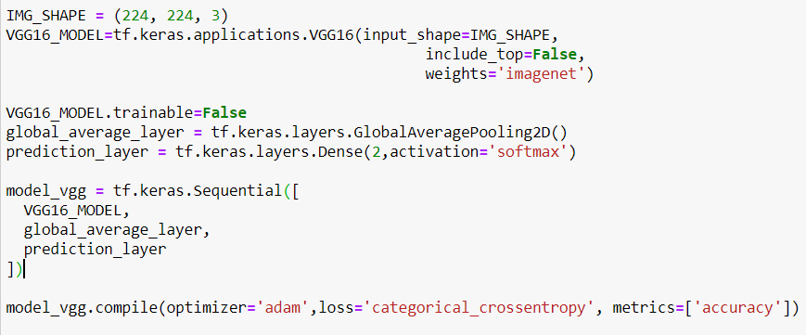

**Fig 2.7** vgg16 model

**2.2.4.3 Result**

This model is used for training of various body and face parts, so we received different accuracy for every part. Accuracy varied from 71% to 79%.

**2.3 Theory used in system**

**2.3.1 Machine Learning vs Deep Learning**

Machine learning is a subset of artificial intelligence associated with creating algorithms that can change themselves without human intervention to get the desired result – by feeding themselves through structured data.

Deep learning is a subset of machine learning where algorithms are created and function similarly to machine learning, but there are many levels of these algorithms, each providing a different interpretation of the data it conveys. This network of algorithms is called artificial neural networks. In simple words, it resembles the neural connections that exist in the human brain.

**2.3.2 Convolution Neural Network**

In neural networks, Convolutional neural network (CNNs) is one of the main categories to do images recognition, images classifications. Objects detections, recognition faces etc., are some of the areas where CNNs are widely used. CNN image classifications take an input image, process it and classify it under certain categories (E.g., Dog, Cat, Tiger, Lion).



**Fig 2.8** CNN Image Classification

A**Convolutional Neural Network (ConvNet/CNN)** is a Deep Learning algorithm which can take in an input image, assign importance (learnable weights and biases) to various aspects/objects in the image and be able to differentiate one from the other. The pre-processing required in a ConvNet is much lower as compared to other classification algorithms. While in primitive methods filters are hand-engineered, with enough training, ConvNets have the ability to learn these filters/characteristics.

The architecture of a ConvNet is analogous to that of the connectivity pattern of Neurons in the Human Brain and was inspired by the organization of the Visual Cortex. Individual neurons respond to stimuli only in a restricted region of the visual field known as the Receptive Field. A collection of such fields overlap to cover the entire visual area.

There are four main operations in the ConvNet:

1. Convolution
2. Non Linearity (ReLU)
3. Pooling or Sub Sampling
4. Classification (Fully Connected Layer)

**2.3.2.1 Convolution**

ConvNets derive their name from the [“convolution” operator](http://en.wikipedia.org/wiki/Convolution). The

primary purpose of Convolution in case of a ConvNet is to extract features from the input image. Convolution preserves the spatial relationship between pixels by learning image features using small squares of input data. We will not go into the mathematical details of Convolution here but will try to understand how it works over images.

Consider a 5 x 5 image whose pixel values are only 0 and 1 (note that for a grayscale image, pixel values range from 0 to 255, the green matrix below is a special case where pixel values are only 0 and 1):

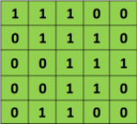

**Fig 2.9** Matrix of 5 x 5

Also, consider another 3 x 3 matrix as shown below:

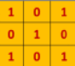

**Fig 2.10** Matrix of 3 x 3

Then, the Convolution of the 5 x 5 image and the 3 x 3 matrix can be computed.

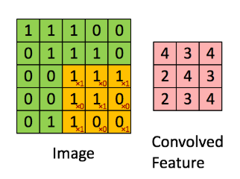

**Fig 2.11** Convolution of two matrix

**2.3.2.2 Non-Linearity (ReLU)**

An additional operation called ReLU has been used after every Convolution operation. ReLU stands for Rectified Linear Unit and is a non-linear operation. Its output is given by f(x)=max(0,x).

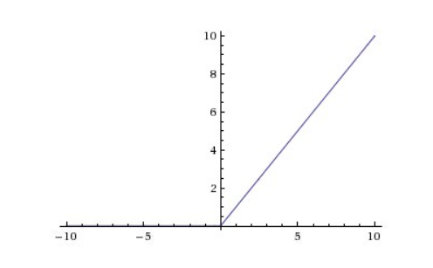

**Fig 2.12** Relu reprentation on graph

**2.3.2.3 Pooling**

Spatial Pooling (also called subsampling or downsampling) reduces the dimensionality of each feature map but retains the most important information. Spatial Pooling can be of different types: Max, Average, Sum etc.

In case of Max Pooling, we define a spatial neighborhood (for example, a 2×2 window) and take the largest element from the rectified feature map within that window. Instead of taking the largest element we could also take the average (Average Pooling) or sum of all elements in that window. In practice, Max Pooling has been shown to work better.

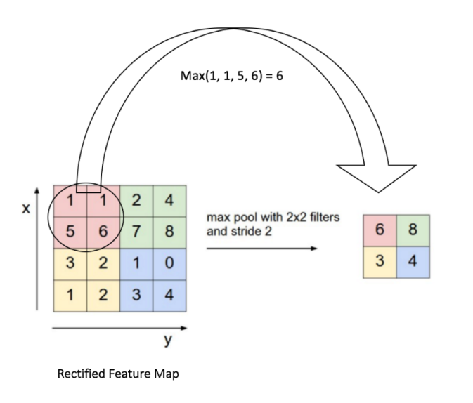

**Fig 2.13** Max pooling

**2.3.2.4 Fully Connected Layer**

The Fully Connected layer is a traditional Multi Layer Perceptron that uses a softmax activation function in the output layer (other classifiers like SVM can also be used, but will stick to softmax in this post). The term “Fully Connected” implies that every neuron in the previous layer is connected to every neuron on the next layer. I recommend [reading this post](https://ujjwalkarn.me/2016/08/09/quick-intro-neural-networks/) if you are unfamiliar with Multi Layer Perceptrons.

The output from the convolutional and pooling layers represent high-level features of the input image. The purpose of the Fully Connected layer is to use these features for classifying the input image into various classes based on the training dataset.

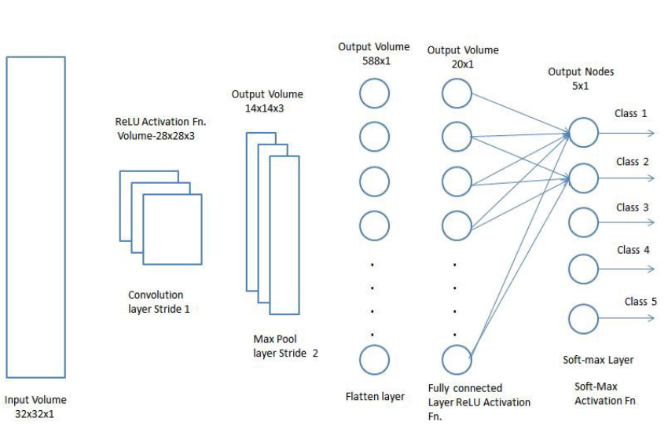

**Fig 2.14** Fully connected Layer

There are various architectures of CNNs available which have been key in building algorithms which power and shall power AI as a whole in the foreseeable future. Some of them have been listed below:

1. LeNet
2. AlexNet
3. VGGNet
4. GoogLeNet
5. ResNet
6. ZFNet

**2.3.3 Image Preprocessing**

The images need to be preprocessed as not all the images are useful nor are the dimensions of the image reconcilable to train the model based on the hardware present with us.

The basic steps for preprocessing the image are: -

Resize/Crop

Reduce the dimensions

Augment the data

**2.3.3.1 Resize/crop**

CNNs are a type of neural network which build progressively higher level

features out of groups of pixels commonly found in the images. How an image scores on these features is then weighted to generate a final classification result. CNNs are the best image classifier algorithm we know of, and they work particularly well when given lots and lots of data to work with.

**Progressive resizing**is a technique for building CNNs that can be very helpful during the training and optimization phases of a machine learning project. Image resizing helps to increase accuracy of model.

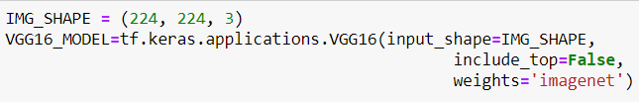

**Fig 2.15** Code Snip $

Here, all images are resized to 224 x 224 pixels dimension.

**2.3.3.****2 Dimensionality Reduction**

In machine learning classification problems, there are often too many factors on the basis of which the final classification is done. These factors are basically variables called features. The higher the number of features, the harder it gets to visualize the training set and then work on it. Sometimes, most of these features are correlated, and hence redundant. This is where dimensionality reduction algorithms come into play. Dimensionality reduction is the process of reducing the number of random variables under consideration, by obtaining a set of principal variables. It can be divided into feature selection and feature extraction.

**2.3.3.3 Data Augmentation**

Data augmentation is the process of increasing the amount and diversity of data. We do not collect new data, rather we transform the already present data. Data augmentation is an integral process in deep learning, as in deep learning we need large amounts of data and in some cases, it is not feasible to collect thousands or millions of images, so data augmentation comes to the rescue. It helps us to increase the size of the dataset and introduce variability in the dataset.

The most used operations are-

1. Rotation
2. Shearing
3. Zooming
4. Cropping
5. Flipping
6. Changing the brightness level

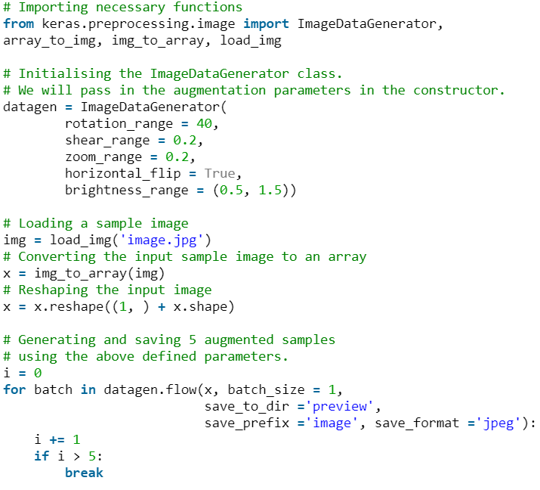

**Fig 2.16** Data Augmentation

**2.3.4 Training/Testing Set**

The total dataset is divided into testing and training set. The training set has images with varied dimensions to extract the most features from the images and determine a learning pattern based on them, which makes the base of the trained model which will be used to predict the set and determine the results.

The testing set follows the same pattern but with less images, and then the results are compared internally to check whether the training results generated the same results or not. Also, the images taken in training and testing set are different to point out varieties in the set of images. This data set more closely refines the images in the set and extracts minute features and use them to test the model and generate a more efficient model for prediction.

**2.3.5 Feature Extraction**

This is the step where we are to extract features from the images. The CNN models and its configuration is loaded here and the training of images are processed in the given configuration. The output is the extracted features and learning based on its data set, which can be used to identify the features in predicting the image.

**2.3.6 Detailed Vgg16 Model**

VGG-16 is a convolutional neural network architecture, its name VGG-16 comes from the fact that it has 16 layers. It’s layers consists of Convolutional layers, Max Pooling layers, Activation layers, Fully connected layers.

The input to cov1 layer is of fixed size 224 x 224 RGB image. The image is passed through a stack of convolutional (conv.) layers, where the filters were used with a very small receptive field: 3×3 (which is the smallest size to capture the notion of left/right, up/down, center). In one of the configurations, it also utilizes 1×1 convolution filter, which can be seen as a linear transformation of the input channels (followed by non-linearity).

The convolution stride is fixed to 1 pixel; the spatial padding of conv. layer input is such that the spatial resolution is preserved after convolution, i.e. the padding is 1-pixel for 3×3 conv. layers. Spatial pooling is carried out by five max-pooling layers, which follow some of the conv.  layers (not all the conv. layers are followed by max-pooling). Max-pooling is performed over a 2×2 pixel window, with stride 2.

Three Fully-Connected (FC) layers follow a stack of convolutional layers (which has a different depth in different architectures): the first two have 4096 channels each, the third performs 1000-way ILSVRC classification and thus contains 1000 channels (one for each class). The final layer is the soft-max layer. The configuration of the fully connected layers is the same in all networks.

All hidden layers are equipped with the rectification (ReLU) non-linearity. It is also noted that none of the networks (except for one) contain Local Response Normalization (LRN), such normalization does not improve the performance on the ILSVRC dataset but leads to increased memory consumption and computation time.

The architecture depicted below is VGG16.

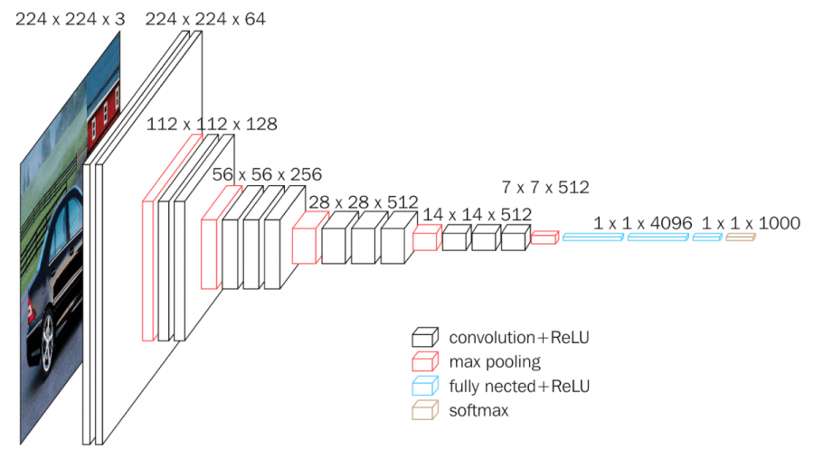

**Fig 2.17** VGG-16 Architecture

**2.4 Detector developed during system implementation**

**2.4.1 Dog body parts detector**

This feature extractor was custom made for this model, as this had some requirements to fulfil, the previous work done till now has features extracted from face, in this section we take it to other body parts and features. We need to extract each body part like face, legs, tail and body separately so that we can user those parts for training individual to identify pet.

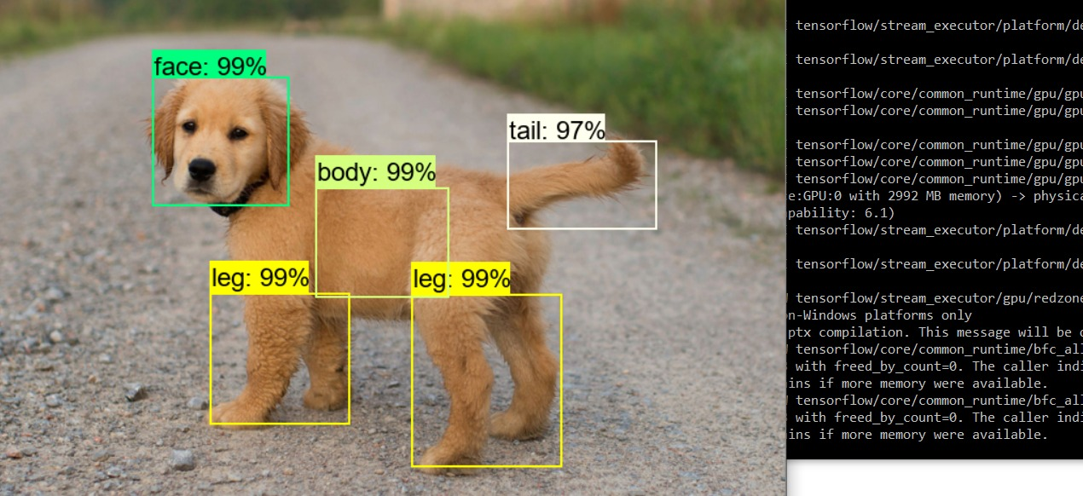**Fig 2.18** Dog Body Parts

**2.4.2 Face parts detector**

Below image shows the work of face parts detector in which we detected eyes, nose and ears separately which will also be used for identifying pet.

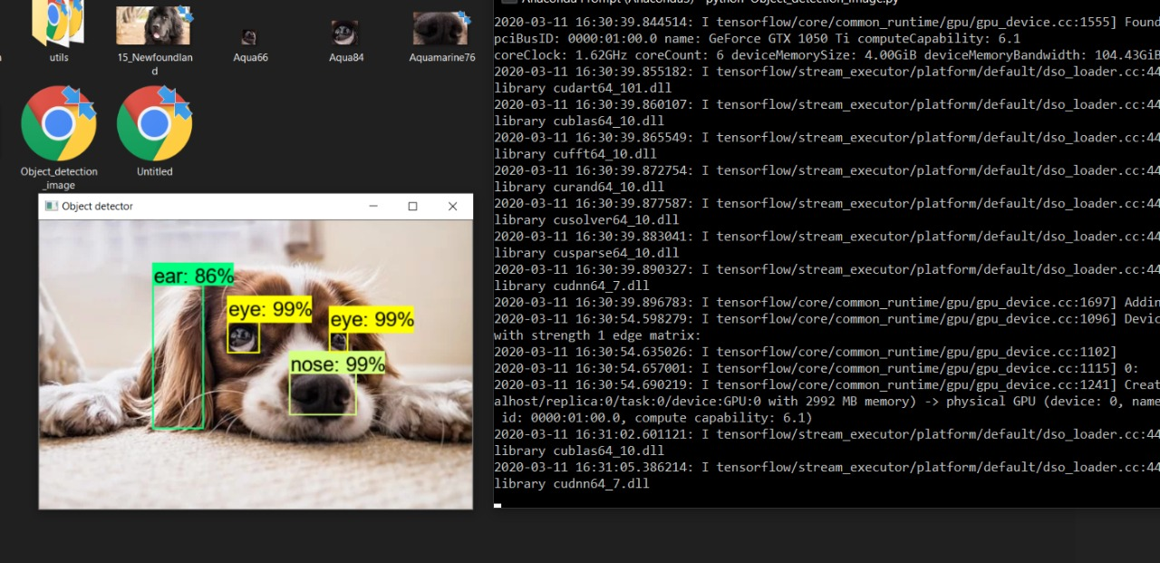

**Fig 2.19** Facial Features

**2.5 API used in system**

**2.5.1 Remove Bg**

Remove-bg provides functionality of removing background from image.

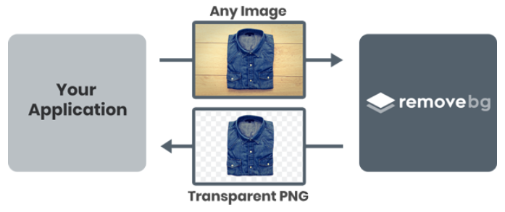

**Fig 2.20** Working of Remove-Bg

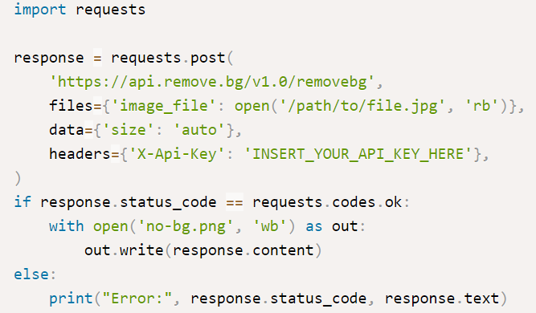

**Fig 2.21** Code Snip 5

**2.6 Tools used during Implementation**

**2.6.1 LableImg**

This was the basic tool used to manually mark and extract features from images. It is a graphical image annotation tool. Annotations are saved as XML files in PASCAL VOC format, the format used by [ImageNet](http://www.image-net.org/). Besides, it also supports YOLO format.

This can identify the hotspots in an image and train the model based on the parts specified reducing the overfitting and under-fitting a most common problem in machine learning, as we have specified which parts of the images are important we are able to train the model at a much faster rate and at a greater accuracy without the risk of overfitting the model as it would be learning the process based on the parts specified.

This creates an xml file for each and every image, we then had to create a python script to merge all the xml files into one common file and then push it for training the model passing the xml as well as the image directory to be trained. Resulting in a commendable output with a faster training rate and higher accuracy.

Hence the model was able to train using hotspots resulting in greater accuracy.

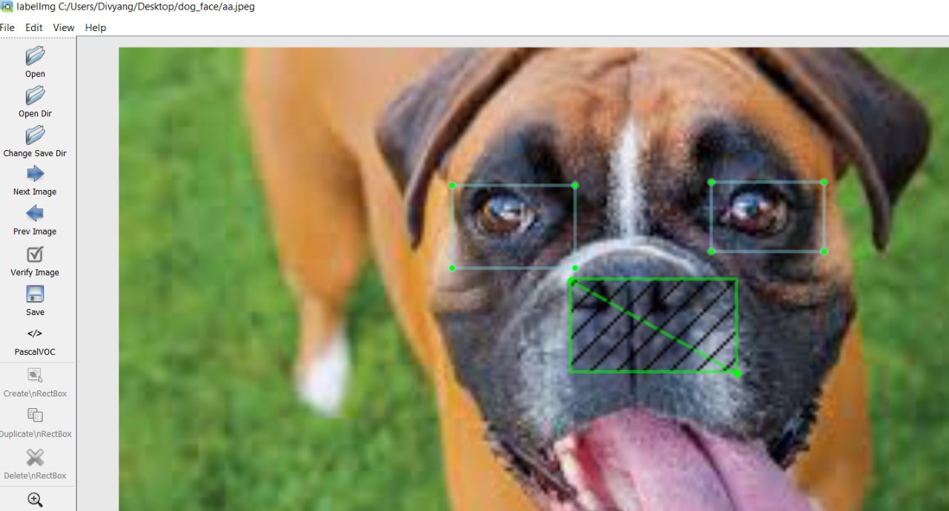**Fig 2.22** LabelImg

**2.6.2 Anvil**

Anvil is a mobile platform to develop and deploy API remotely by just using python, with minimal or no requirement of Javascript to launch the API.

It can integrate between different API’s or expose its REST API and be running in just a few lines of code.

Anvil provides a web-based IDE, removing the need for creating and deploying a localhost web server to host the files. It follows an interface similar to Visual Studio which provides drag and drop options to create a light and simple webpage. Anvil also provides functionality to run python directly from server to clients.

It has a built-in database which can be used to store sql like structured data useful in storing and fetching information, for as supposed to save different profiles of users in different database.

Anvil also provides connection with local script codes so as to run the piece of code on your own machine, so as to use your own resources and prevent the data being leaked onto the online world, it would just be passing the input, function name, function variables, and then when the output is generated it just passes out the output of the function. This makes it easier to run code as we just need to pass the name of the function to be called and the associated attributes which executes the code on a local machine and sends the output to anvil.

It also provides functionality to write HTML, CSS and JS and call the functions from python to deploy a custom layout and generate the website.

Thus, making Anvil perfect for our code deployment which would be deployed online instantly, and we can check out the real time working of the models we have generated.

**2.6.2.1 Connection**

The anvil code is used to connecte with a front end to back end using a key, which uniquely identifies the code and links the code to our Jupyter Notebook file. Anvil provides the server-key and client-key from its uplink interface to link the application to any of your choice of machine and code.

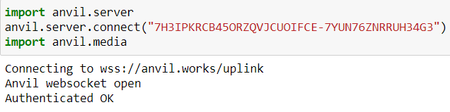

**Fig 2.23** Code Snip6

**2.6.2.2 Layout**

Creating the layout in Anvil is as simple and same as the Visual Studio, it provides with similar tabs of design and code to write and invoke the backend function of the given code.

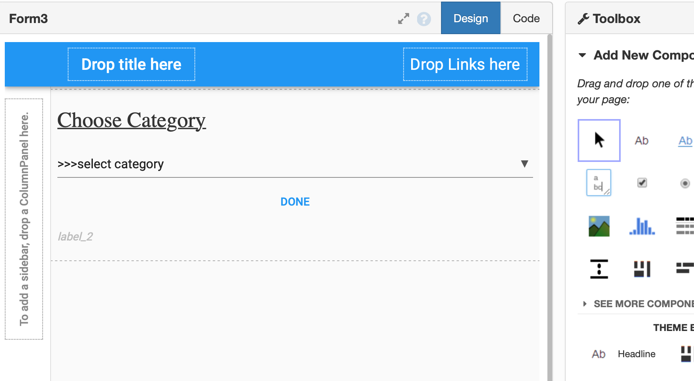

**Fig 2.24** AnvilLayout

The code part looks like this: -

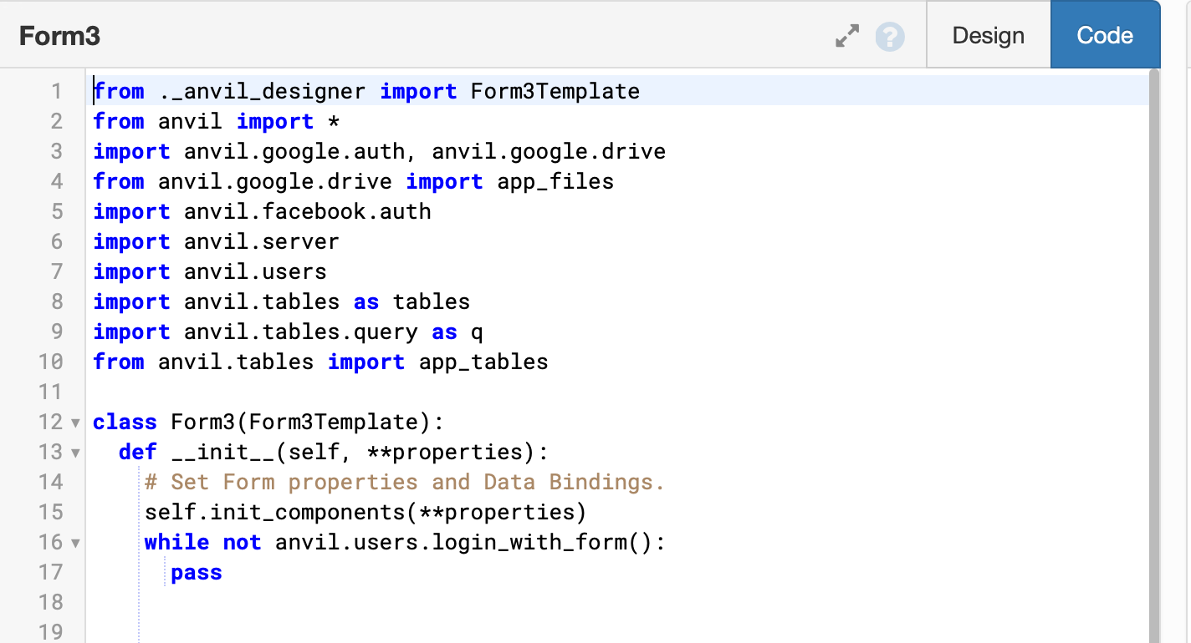**Fig 2.25** Code Snip 7

**Chapter 3**

Analysis

_______________________________________________________________________________________________________

**3 Analysis**

**3.1 Sequence Diagram**

Uml Sequence Diagrams are interaction diagrams that detail how operations are carried out. They capture the interaction between objects in the context of a collaboration. Sequence Diagrams are time focus and they show the order of the interaction visually by using the vertical axis of the diagram to represent time what messages are sent and when.

**3.1.1 Benefits of sequence Diagram**

* Sequence diagrams are used to explore any real application or a system.
* Sequence diagrams are used to represent message flow from one object to another object.

**3.1.2 Login Scenario**

Sequence diagram shows how a login operation is carried out.

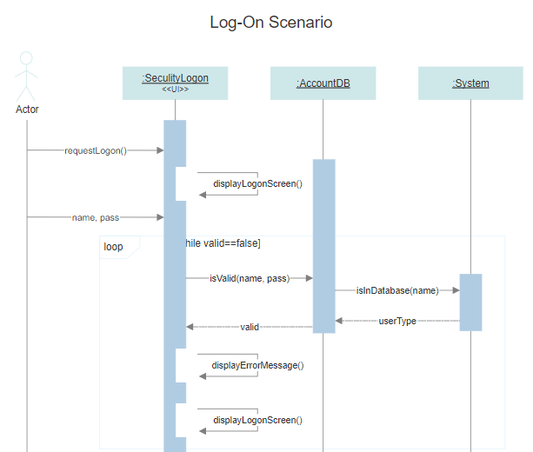

**Fig 3.1** Login Scenario

**3.1.3 Predict Dog Breed**

Below sequence diagram shows how a prediction is carried out in from actor to system.

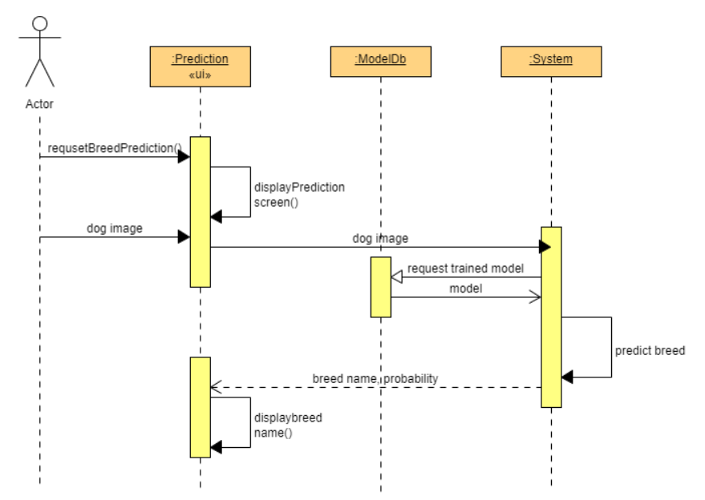

**Fig 3.2** Breed Prediction Scenario

**3.1.4 Dog Face Part Detector**

Below diagram shows how a dog face detector is used in system.

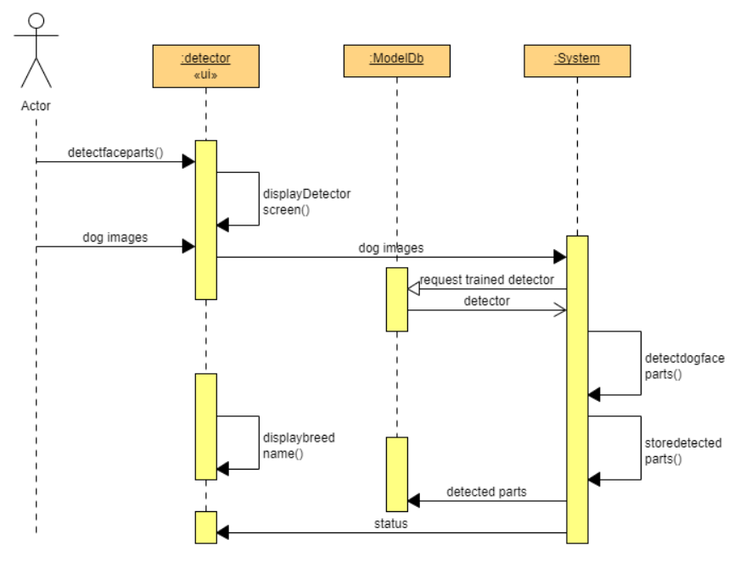

**Fig 3.3** Dog Face Part DetectionScenario

**3.2 Usecase Diagram**

The purpose of use case diagram is to capture the dynamic aspect of a system. However, this definition is too generic to describe the purpose**. U**se case diagrams consists of actors, use cases and their relationships. The diagram is used to model the system/subsystem of an application. A single use case diagram captures a particular functionality of a system.

**3.2.1 Benefits of sequence Diagram**

Benefits of use case diagrams can be said to be as follows:

* Used to gather the requirements of a system.
* Used to get an outside view of a system.
* Identify the external and internal factors influencing the system.
* Show the interaction among the requirements are actors.

**3.2.2 System Usecase diagram**

Below diagram shows the usercase diagram of system.

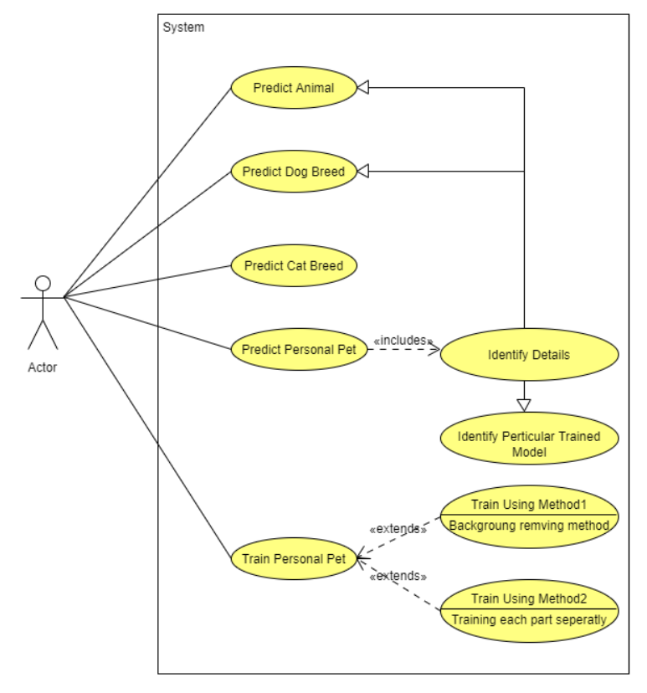

**Fig 3.4** Usecase Diagram

**Chapter 4**

Design

_______________________________________________________________________________________________________

**4. Design**

**4.1 Dataset**

**4.1.1 User Details**

Usage: Used to store login criteria of user and to manage session.

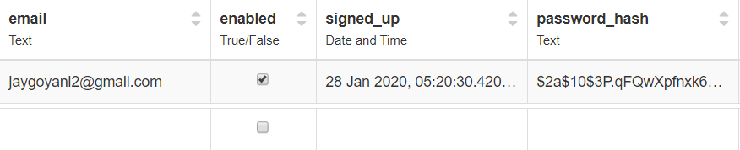

**Fig 4.1** User Data

**4.1.2 Cat_or_Dog Feedback**

Usage: To store feedback of user that predicted animal category is correct or not.

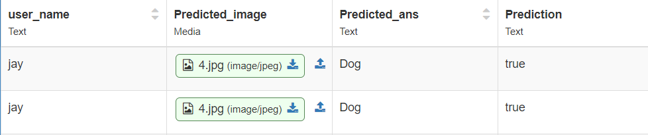

**Fig 4.2** Cat vs Dog Feedback Data

**4.1.3 Breed Feedback**

Usage: To store feedback of user that predicted breed is correct or not.

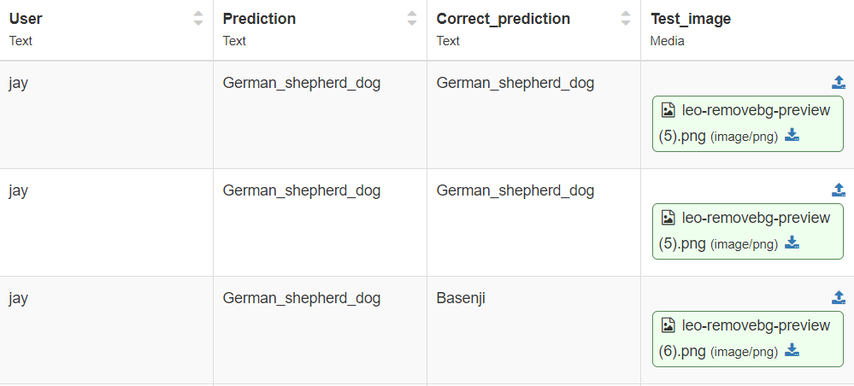

**Fig 4.3** Breed Feedback Data

**4.2 Validations**

**4.2.1 Login Validation**

Register criteria: Facebook,

Google,

Gmail

Login Criteria: Facebook,

Google,

Gmail

User details is used to perform validation.

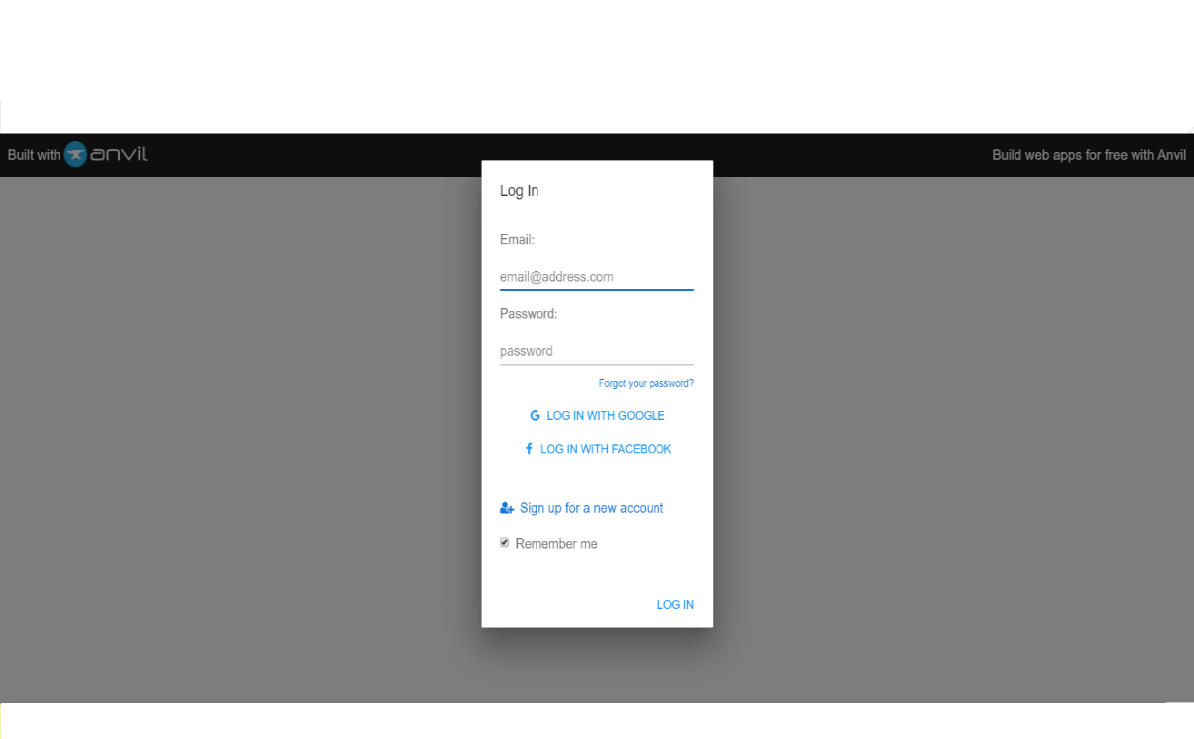

**Fig 4.4** Login and Signup Page

**4.2.2 Dog Face Validation**

Dog face validation is required to detect dog face in images uploaded by user for training so no wrong images are trained during training faze. For this part we had created our own custom (dat) file for detecting heads, nose, eyes, eyebrows, ears etc. From xml file the xml files were manually labeled using a software named labelImg, which uses pyqt and is purely based on python.

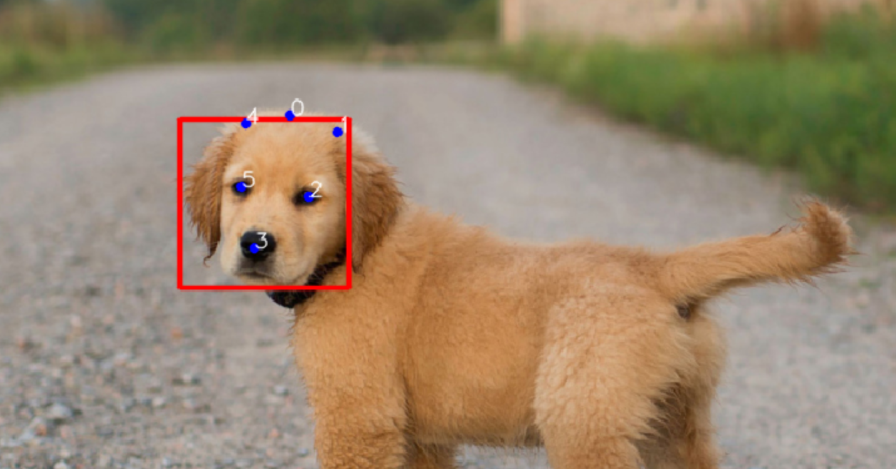

**Fig 4.5** Dog Face Detector

**Chapter 5**

Implementation

_______________________________________________________________________________________________________

1. **Implementation**

**5.1 Home Page**

Usage: Home page is implemented so user can easily navigate entire application easily and can every feature with minimum interaction. The user can choose from any 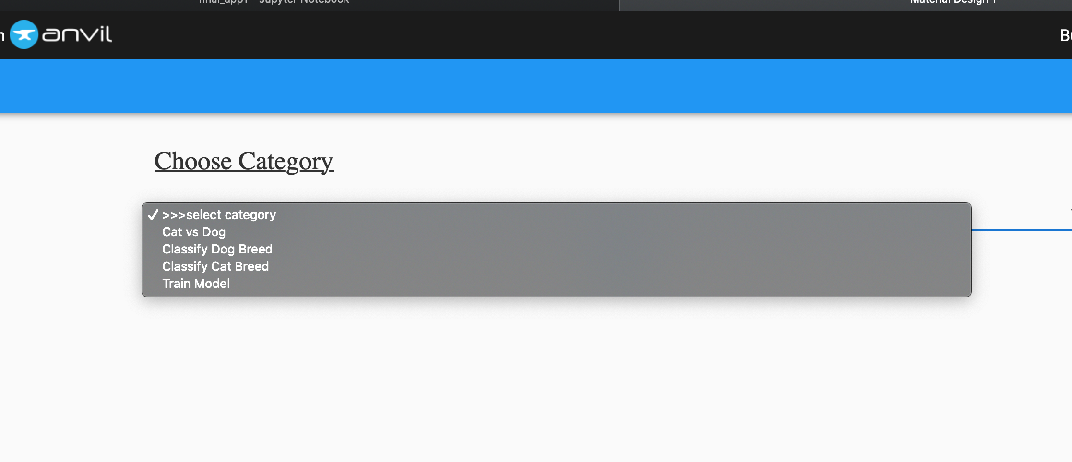one of the tasks to perform.

**Fig 5.1** Anvil Snip 1

**5.2 Cat vs Dog Classifier**

Usage: This functionality is based on model in **Ch. 2.2.1** which is used to predict the correct animal (cat or dog).

Here the user can upload the picture of a dog or a cat and the model would print an 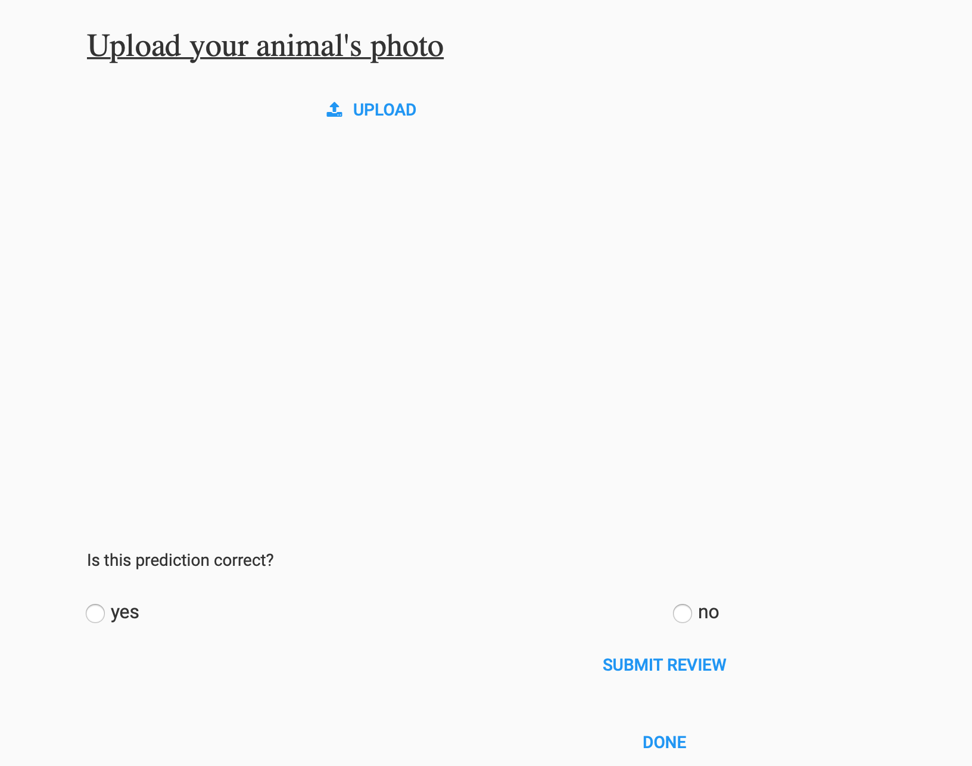output showing the prediction result.

**Fig 5.2** Anvil Snip 2

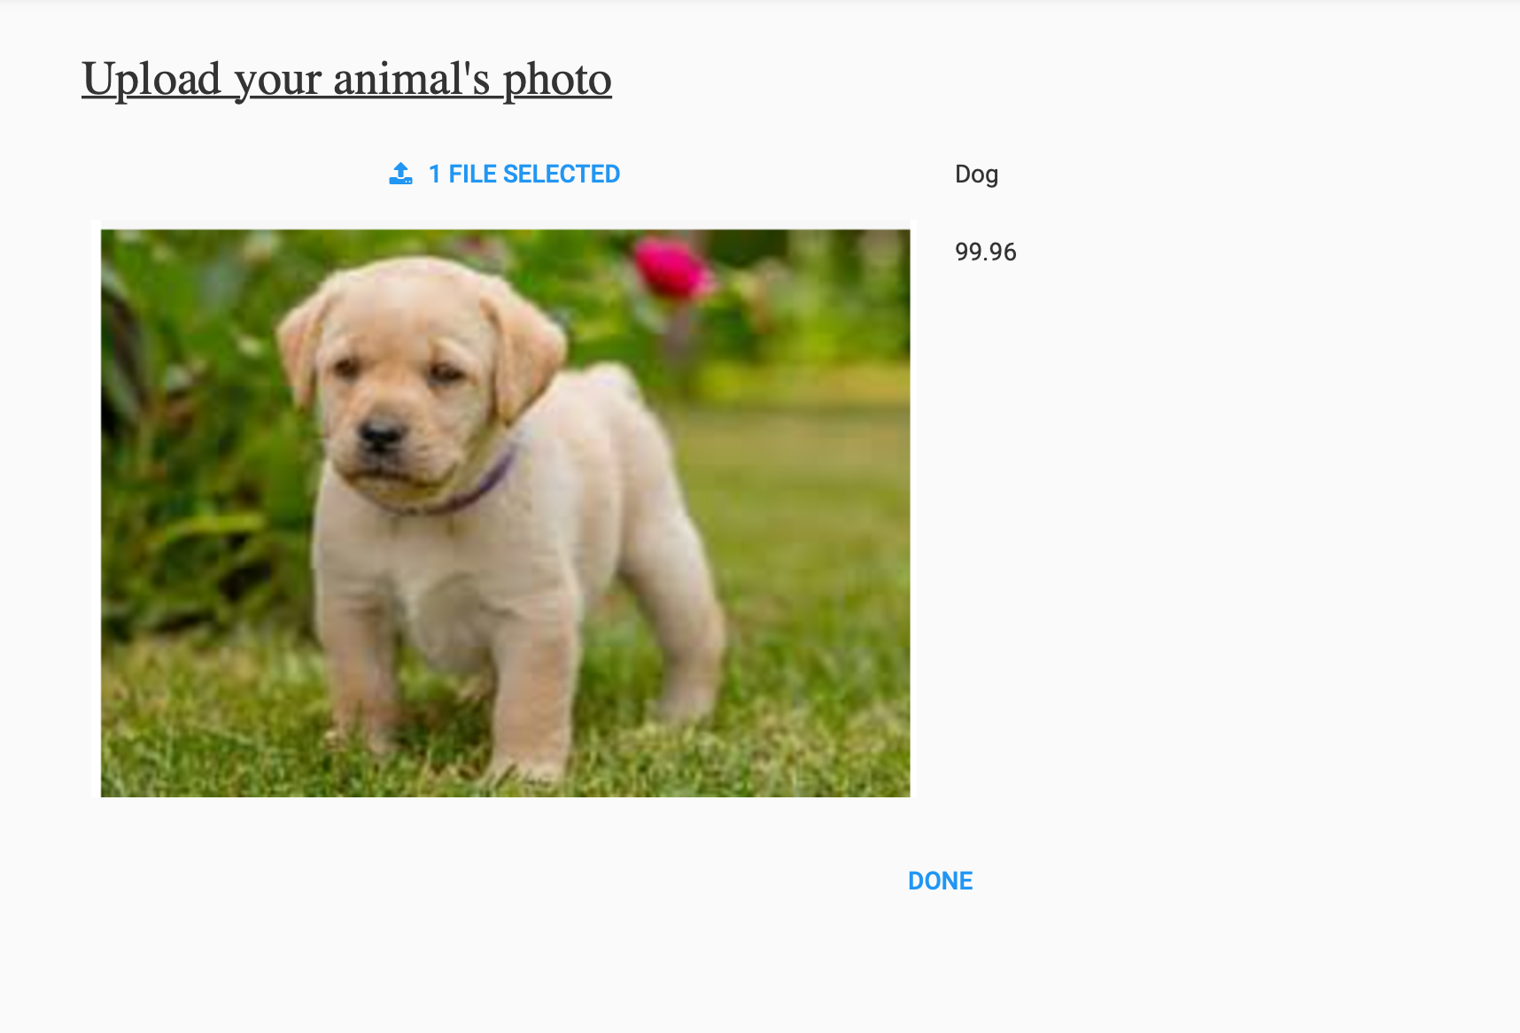The output is shown below: -

**Fig 5.3** Anvil Snip 3

**5.3 Dog Breed Classifier**

Usage: This uses the Dog Breed model in **Ch. 2.2.2** Here the user needs to upload the picture of dog, of which the user wants to know the breed of. Out of the 175 Breeds of dog, it would match and identify the breed which closest resembles to the one with the highest probability would be shown as output here:

**Fig 5.4** Anvil Snip 4

The output here shows the prediction result along with the accuracy percentage of the breed.

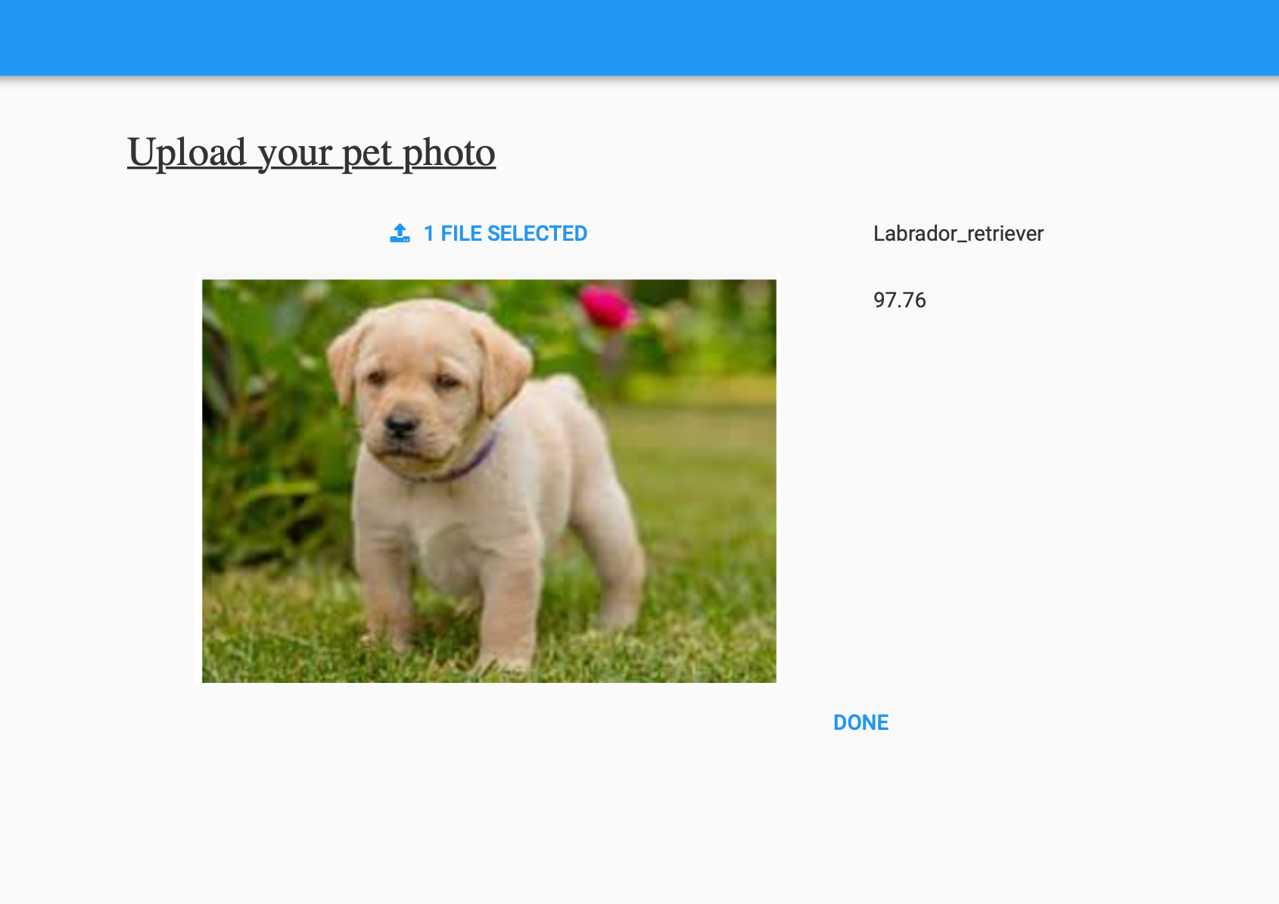The output is shown as below: -

**Fig 5.5** Anvil Snip 5

**5.4 Cat Breed Classifier**

Usage: Out of the 70 Breeds of Cat, it would match and identify the breed which closest resembles to the one with the highest probability would be shown as 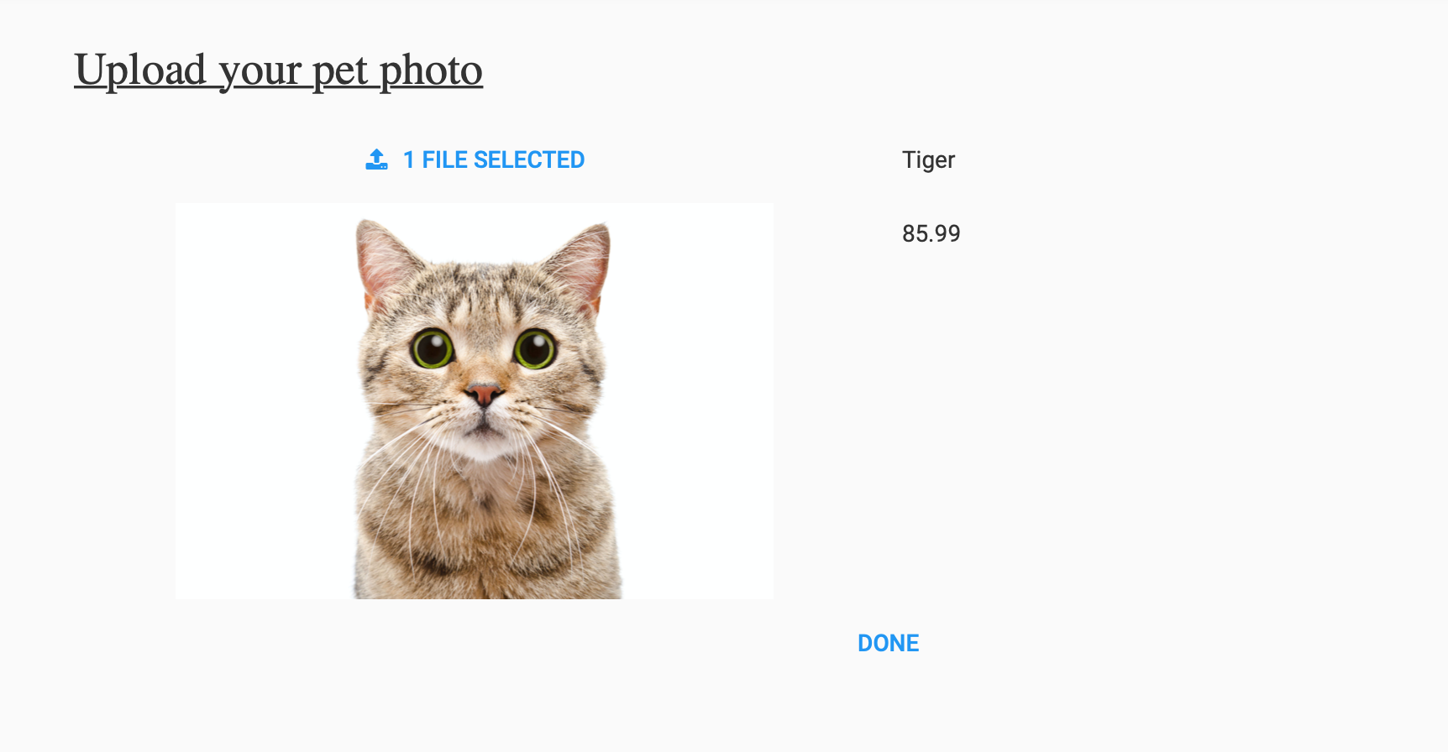output here.

**Fig 5.6** Anvil Snip 6

**5.5 Feedback form for cat vs dog classifier**

Usage: We need to update our dataset from time to time in near real time or in batch processing, so we don’t have static dataset and out model is updated as and when required.

Feedback is also important to identify that our trained model is accurate for user or not.

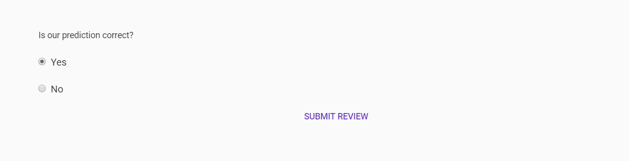

**Fig 5.7** Anvil Snip 7

Feedback will be stored in database showed in **Ch. 3.1.2**

**5.6 Feedback form for dog breed identifier**

Usage: Feedback form for dog breed classifier is used to identify if the model is predicting breed correctly. Feedback will be stored in database showed in **Ch. 3.1.3**



**Fig 5.8** Anvil Snip 8

If user provides prediction as incorrect, we need to take correct breed name from user.

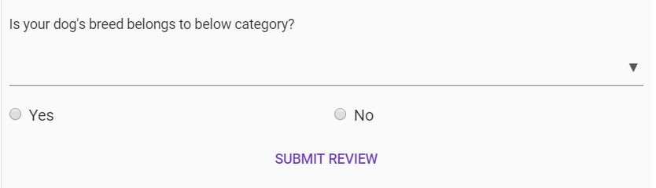

**Fig 5.9** Anvil Snip 9

If dog’s breed is not one of the 175 breeds, so we can add new breed in our dataset if user upload good number of images of wrongly predicted dog’s breed.

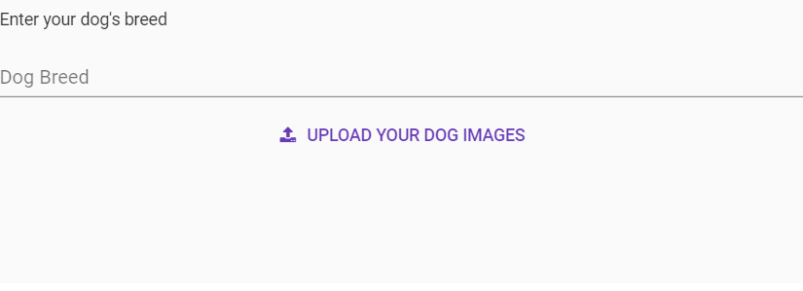

**Fig 5.10** Anvil Snip 10

**5.7 Pet Trainer (Using background extraction)**

Usage: This provides functionality to train a pet (dog) with model discuss in **Ch: 2.2.3**

After user uploads images for training, all the images must go through testing in which dog face validation will be used as discuss in **Ch: 3.2.2.** After validation is performed all the images will go through data augmentation to overcome overfitting and then dataset will go for training using VGG model.

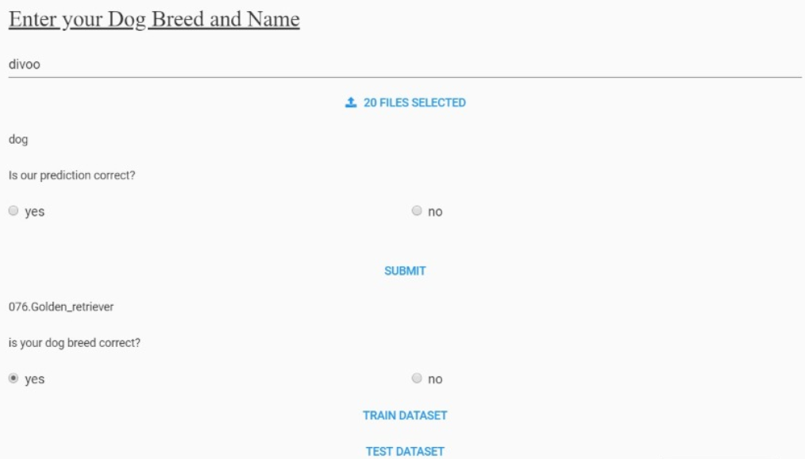

**Fig 5.11** Anvil Snip 11

**5.8 Pet Prediction**

After the pet model is trained if user uploads any images of his/her personal pet we need to predict correct pet out of all trained model of user’s pet because user may have more than one pet.

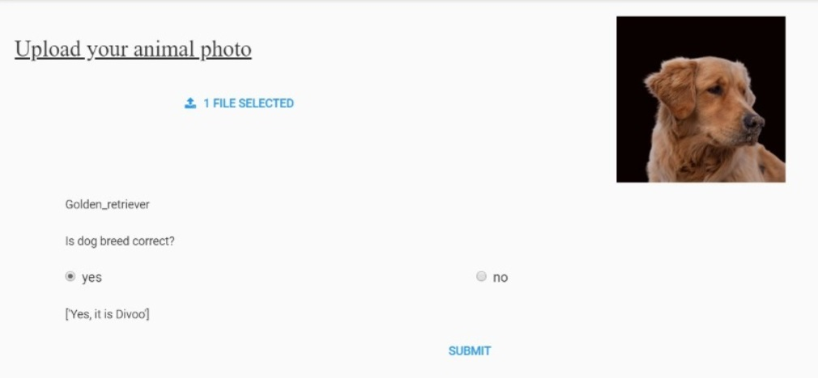

**Fig 5.12** Anvil Snip 12

**5.9 Body Parts Detector**

Usage: This functionality will separate all body parts from all images uploaded by users in appropriate directory. Which will be used for training later.

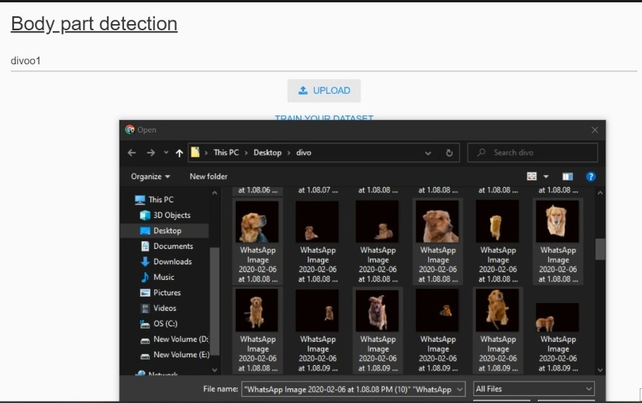

**Fig 5.13** Anvil Snip 13

**5.10 Face Parts Detector**

Usage: This functionality will separate all face parts from all images uploaded by users in appropriate directory. Which will be used for training later.

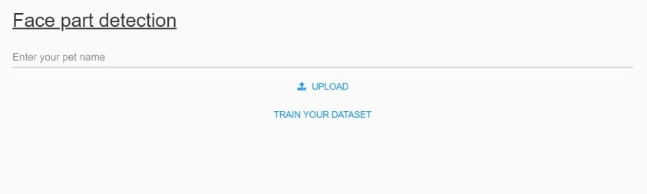

**Fig 5.14** Anvil Snip 14

**5.11 Pet Trainer (Using body and face parts)**

Usage: After all body and face parts are gathered, we need to send those images for training. This work will be carried out by this specific page, which will use model discussed in **Ch: 2.2.4**.

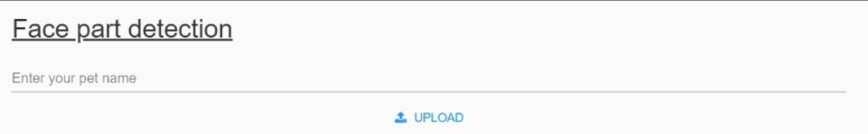

**Fig 5.15** Anvil Snip 15

**Chapter 6**

Conclusion and Future Extensions

_______________________________________________________________________________________________________

**6. Conclusion and Future Extensions**

**6.1 Conclusion**

We see major contributions to the literature in this project. Our keypoint predictions were 4.62 pixels from the ground truth points on average. The accuracy of our keypoint detection allowed us to succeed with our classification algorithms and is promising for future work in the area. Our vast experimentation with classification algorithms also provides novel contributions to the literature. The use of color histograms in feature extraction has been a key point in extracting features however, we found them to be unsuccessful due to the variety in color for individuals of the same breed. We also experimented with a variety of linear classifiers such as logistic regression and K-nearest neighbors for predicting dog breeds. These contributions add a variety of techniques to the literature for dog breed identification some which should be explored further as will be discussed next.

We advanced dog identification from a new perspective, using facial features. To the best of our knowledge, as existing art mostly sees animals as groups, not as individuals. Although ecologists have growing interest in identifying individual wild animals, pet identification is a new frontier for computer vision.

Data acquisition was the bottleneck for growing those datasets, as the manual annotation is very laborious. However, while keeping data acquisition manageable, we have shown that facial recognition in dogs is possible with accuracies much above pure chance. We hope that this work will spark the interest of other groups, and allow more aggressive, collective, efforts of data acquisition.

The performance of off-the-shelf classical Human Facial Recognizers was rather poor for dogs, showing that dog facial recognition is not a trivial extension of human facial recognition. Convolutional Networks, both shallow and deep, proved more successful. A very deep pre-trained Overfit network — CUSTOM — showed the best results, with the shallow network with special architecture optimization achieving a very decent second best. The performance was very promising, especially when contrasted to the literature that shows that dog recognition is hard even for human dog experts, with 81% accuracy in optimal conditions.

Our results also suggest margin for improvement with more training samples per individual. This suggests that for the optimal operation of a real-world system, owners should be stimulated to register as many pictures as possible.

Our main motivation is to evaluate if pet biometry can be useful for retrieving lost animals, complementing existing solutions like dog tags, tattoos and micro-chips, that require special forethought, or may be lost.

We also foresee applications beyond finding lost pets. Ecologists have growing interest in identifying individual wild animals, to detect migration patterns. There is also a forensic interest, in the case of stolen horses and cattle. We would like to address those exciting use cases, extracting features from the rest of the animal, not only the face. For certain animals, the coat can provide clues even more distinctive than the face, but because animals are deformable objects, getting invariant enough features is very challenging

**6.2 Future Extension**

In the current version of the application, pets are identified using body and face parts like nose, ears, eyes, tail, leg and body portion. In extension to these other features like identifying dog by it’s height, size, body color and prints on body parts will be included. It will help to improve in identification of dogs of same breed.